1. Write a Python program to print the following string in a specific format (see the output).

Twinkle, twinkle, little star,

How I wonder what you are!

Up above the world so high,

Like a diamond in the sky.

Twinkle, twinkle, little star,

How I wonder what you are

Ans] 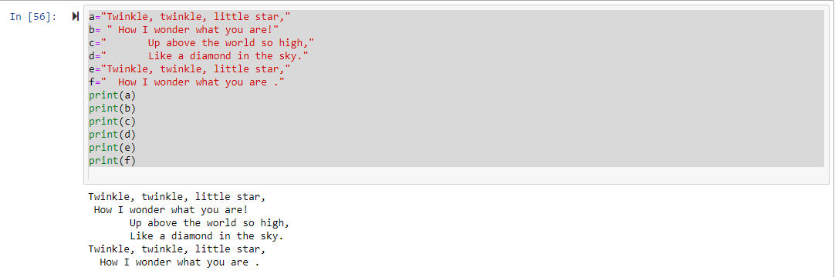

1. Write a Python program to get the Python version you are using ?

Ans]

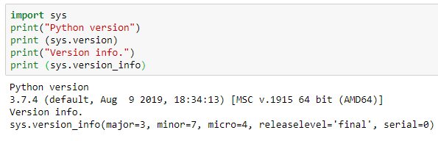

1. Write a Python program to display the current date and time?

Ans]

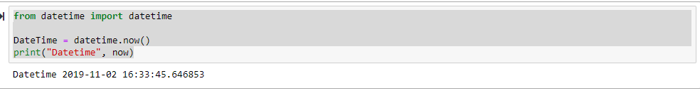

6. Write a python program which takes two inputs from user and print them addition

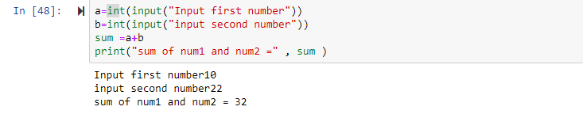

1. Write a Python program which accepts the user's first and last name and print them in reverse order with a space between them

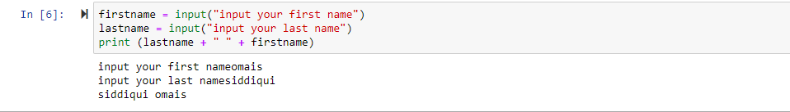Ans]

1. Write a Python program which accepts the radius of a circle from the user and compute the area?

Ans]

